Homework M4: Release Automation
Main goal is to build further on what was demonstrated during the practice
Prerequisites may vary between different tasks. You should adjust your infrastructure according to the task you chose to implement

Tasks
Choose and implement one or more of the following:
- Come up with a fully (all tags) parametrized version of the docker-compose.yaml file in part 1
- Add deployment job to the rest of the Gitea pipelines from part 1
- Add deployment stages for the rest of the components in the Jenkins pipeline from part 1
- Split the Helm chart from part 3 to a few individual charts – one for every component
* The focus should be on achieving the required and not on doing it in the most automated way possible
** Please note that even if you choose to implement more than one task, they may be quite independent and different. So, you may need to create a separate infrastructure (environment) for each or at least clean it every time

Proof
Prepare a document that shows what you accomplished and how you did it. It can include (not limited to):
- The commands you used to achieve the above tasks
- A few pictures showing intermediary steps or results
1. Parametrized version of all components in docker-compose-file
1.1. Front-End
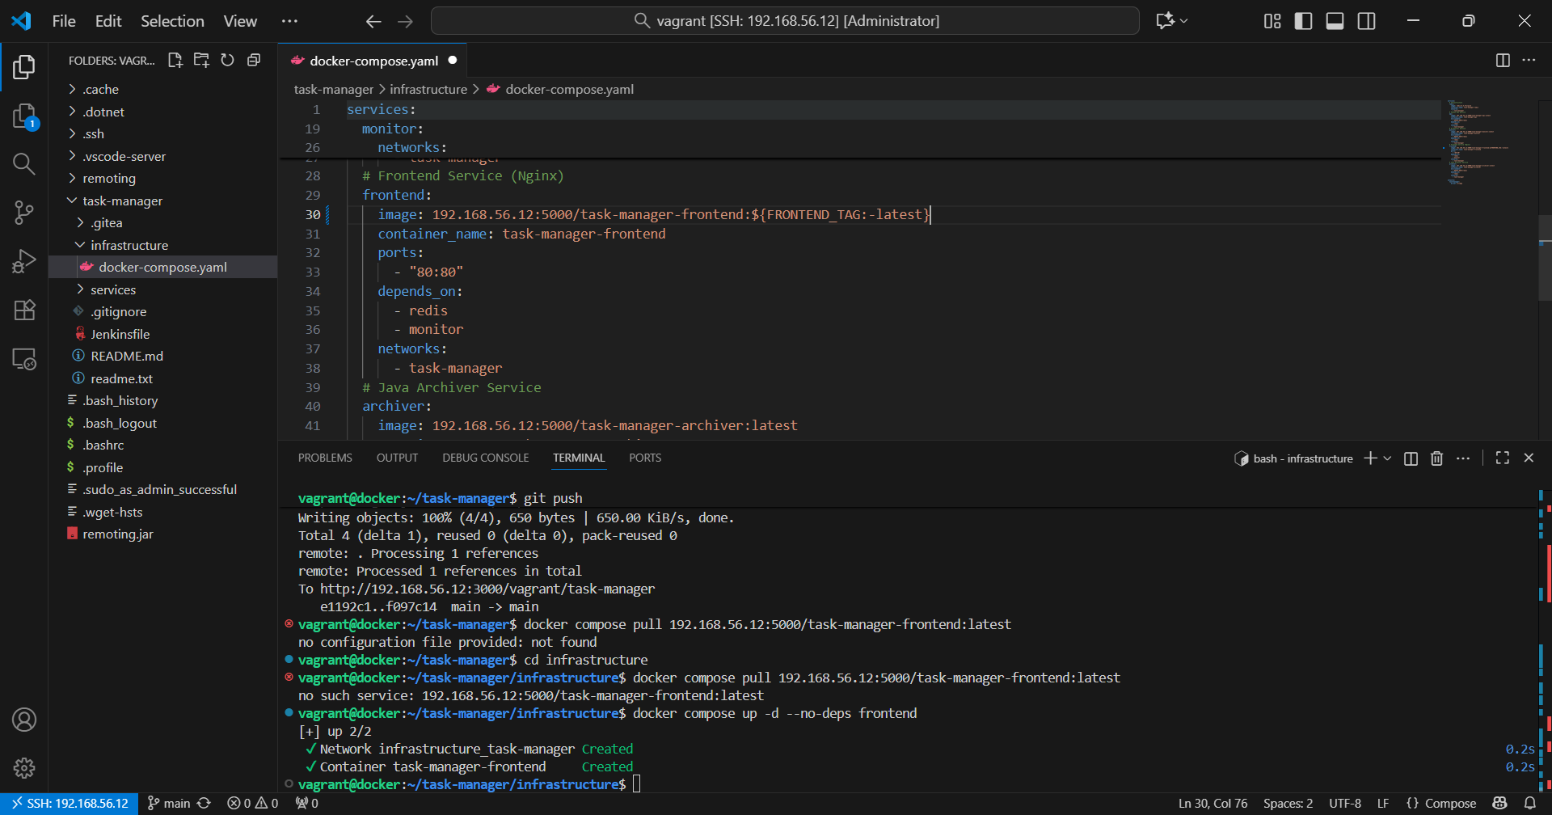
1.2. API
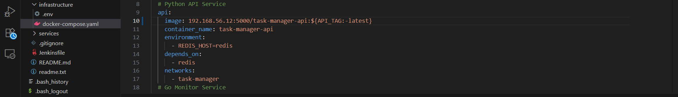
1.3. Archiver
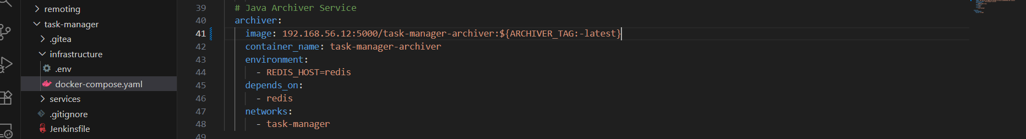
1.4. Monitor
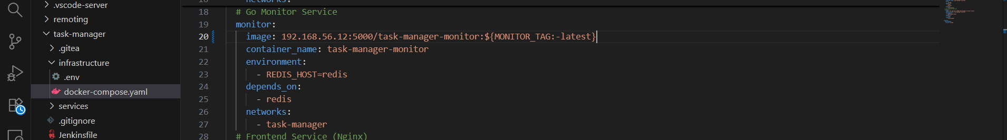

2.Adding deployment jobs for all CI pipelines in Gitea
2.1. Front End
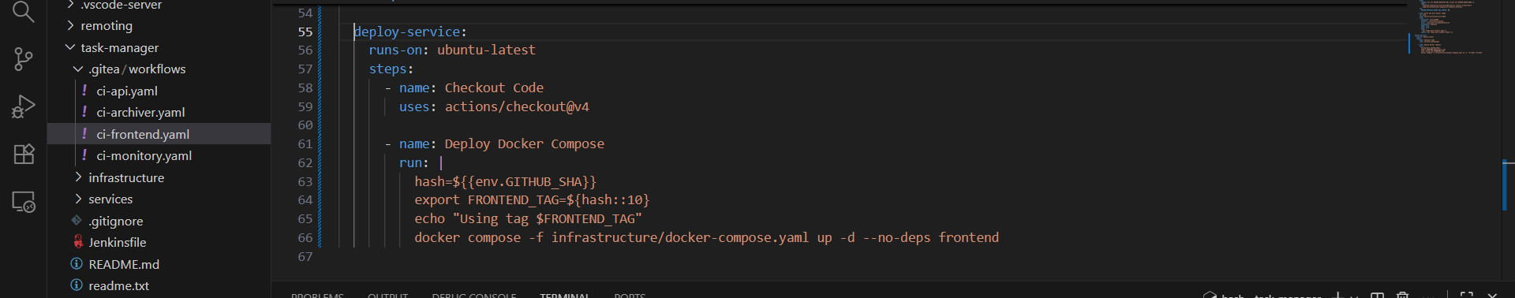
2.2. API
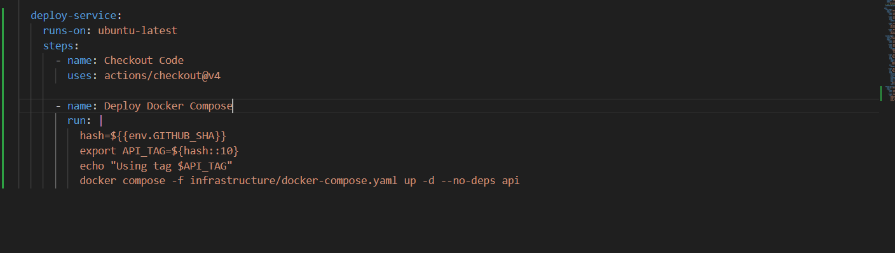
2.3. Monitoring
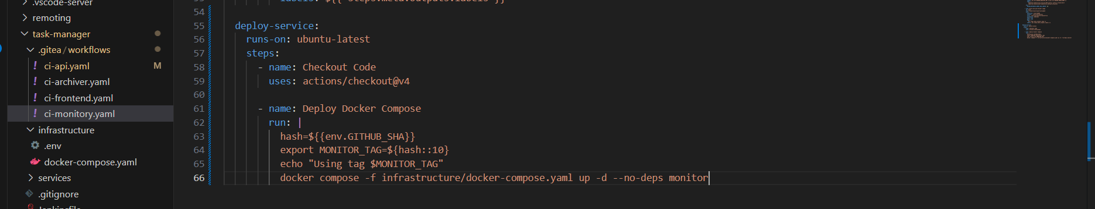
2.4. Archiver
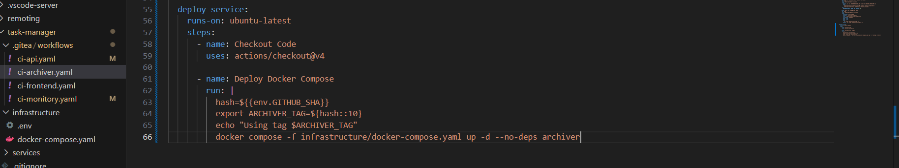

3.Adding deployment stages for all services in Jenkinsfile
3.1. Front End
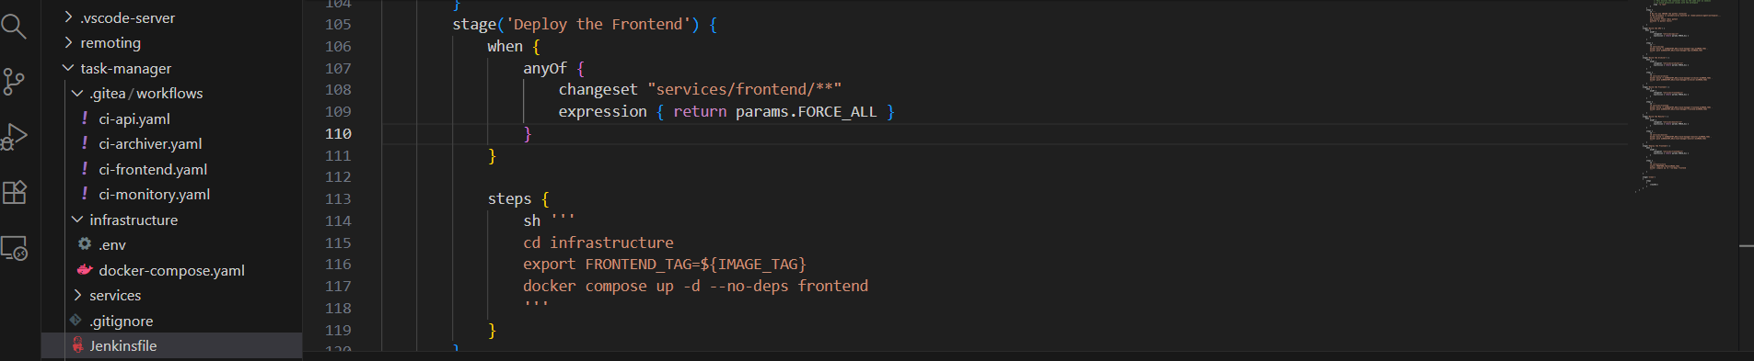
3.2. API
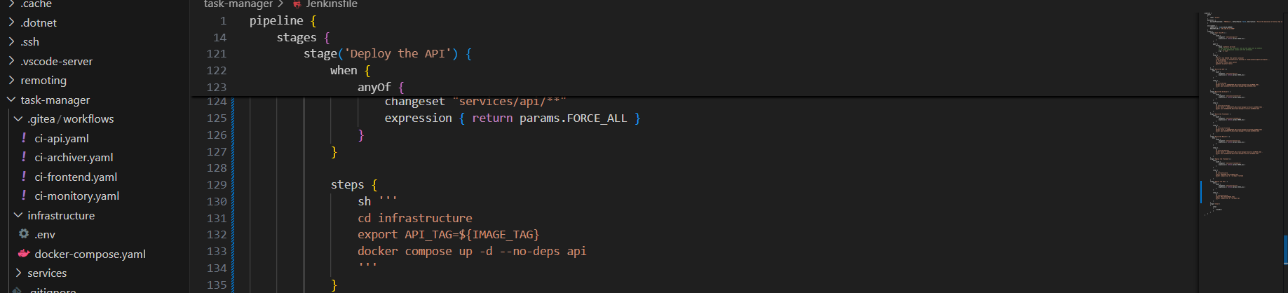
3.3. Monitor
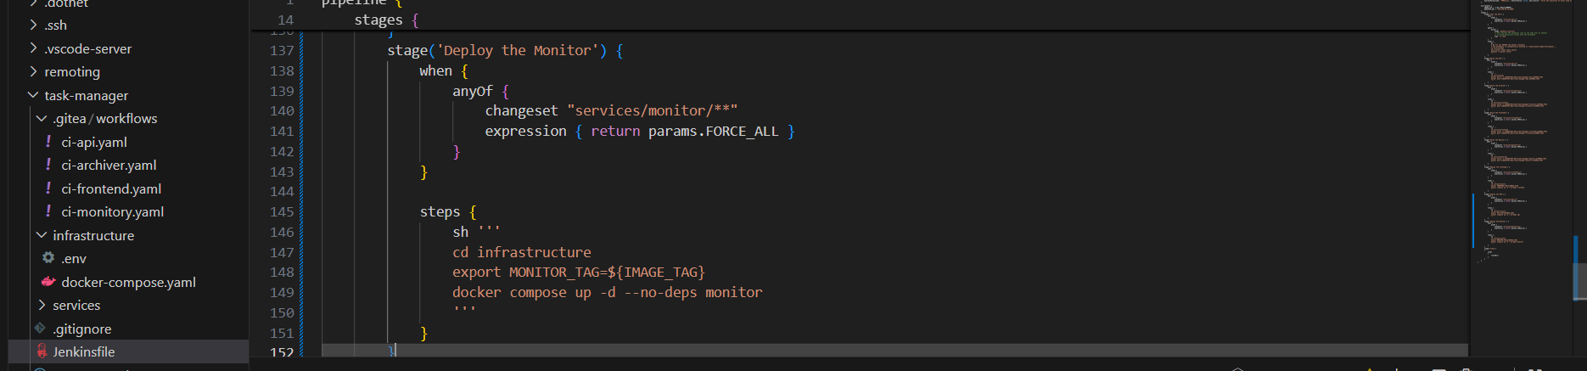
3.4. Archiver
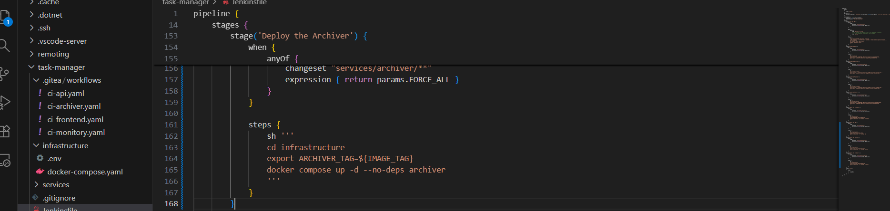
4. Spliting HELM chart to individual service charts
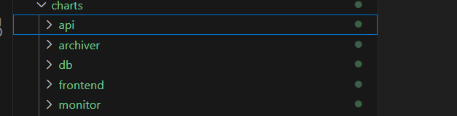
4.1. API
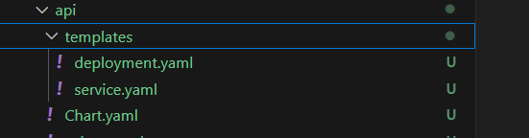\
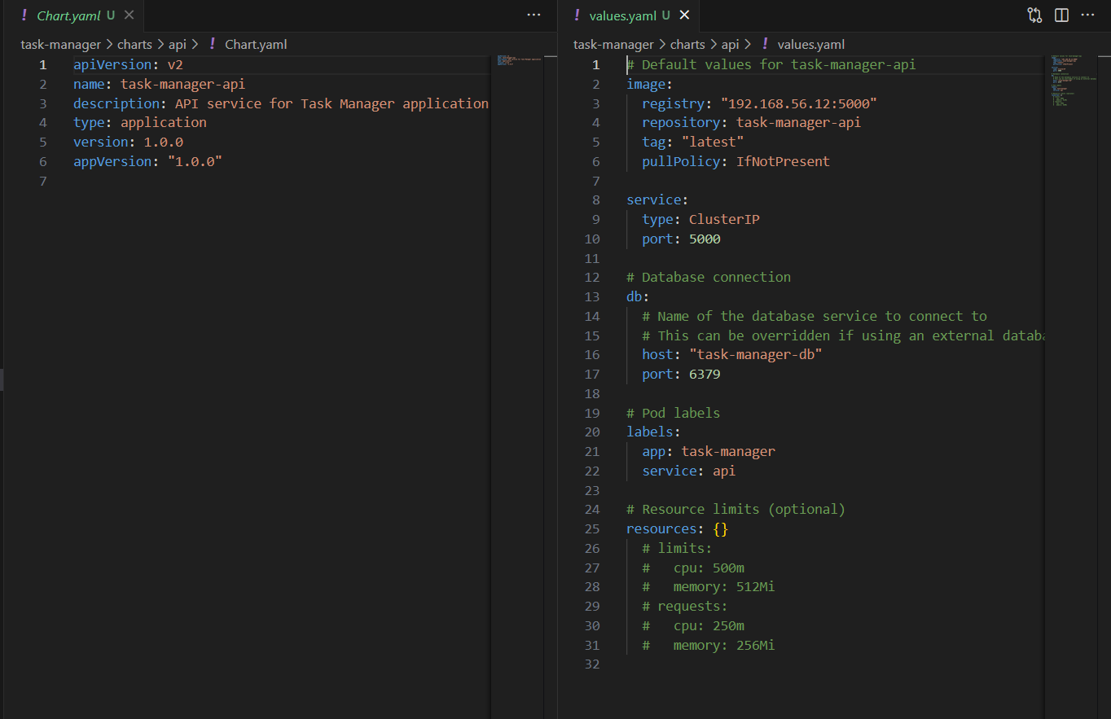
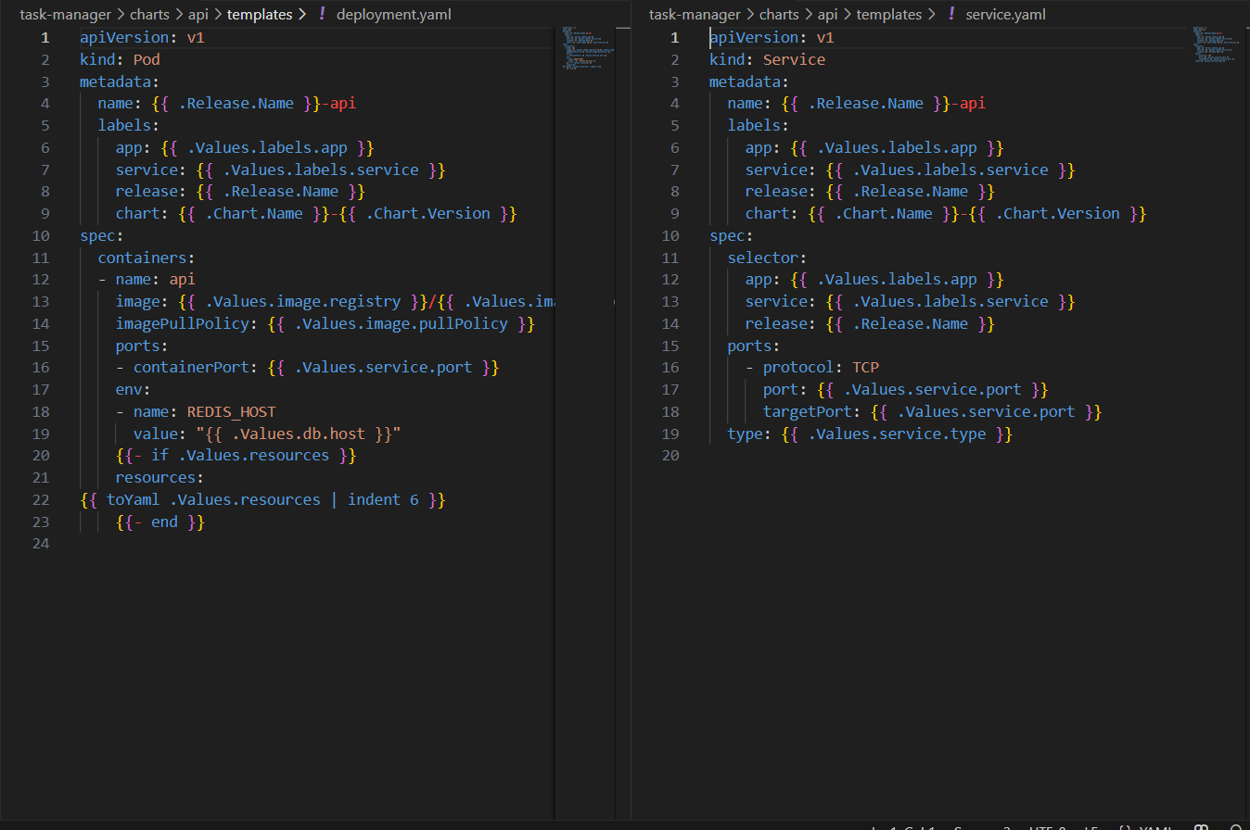
4.2. Archiver
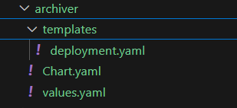
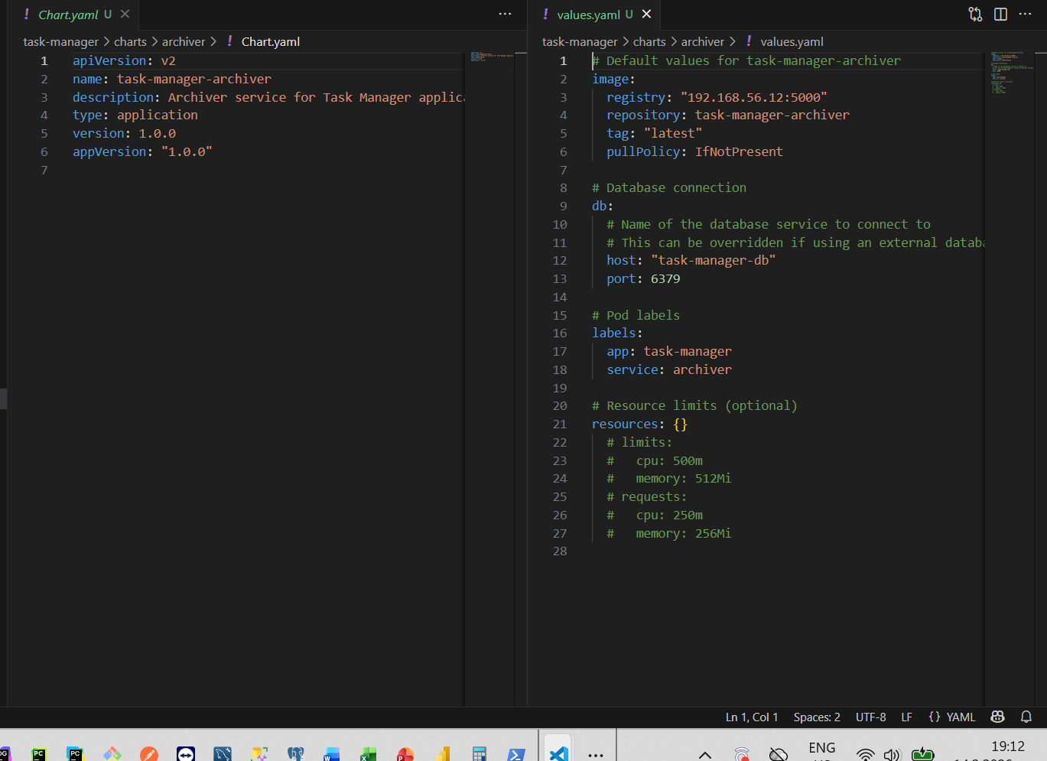
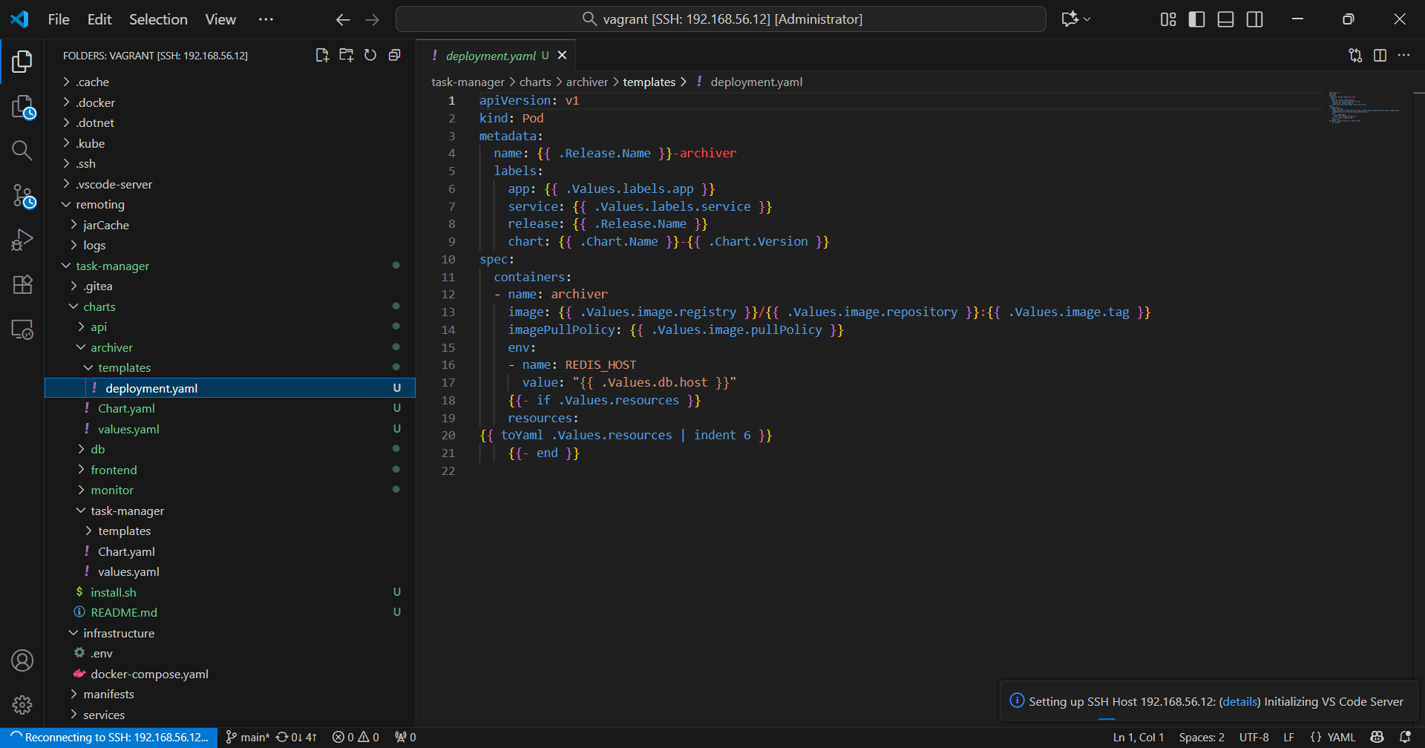
4.3 DB
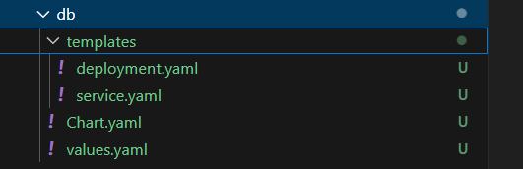
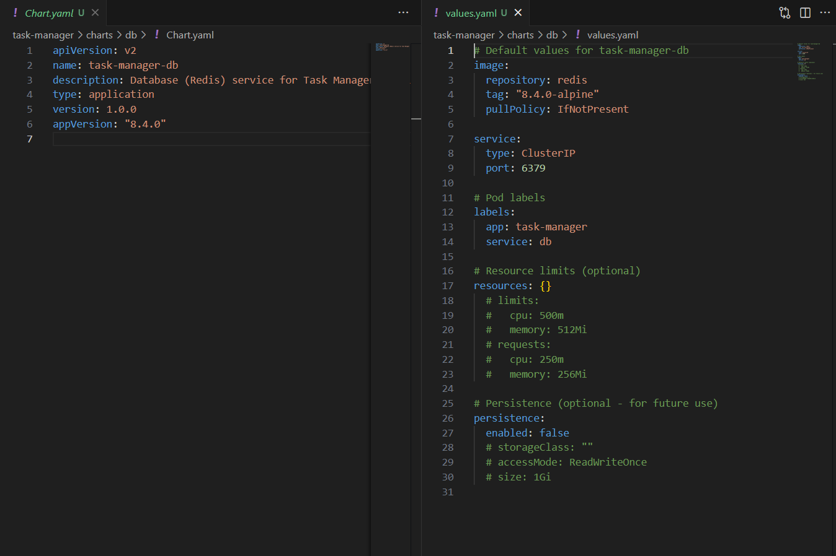
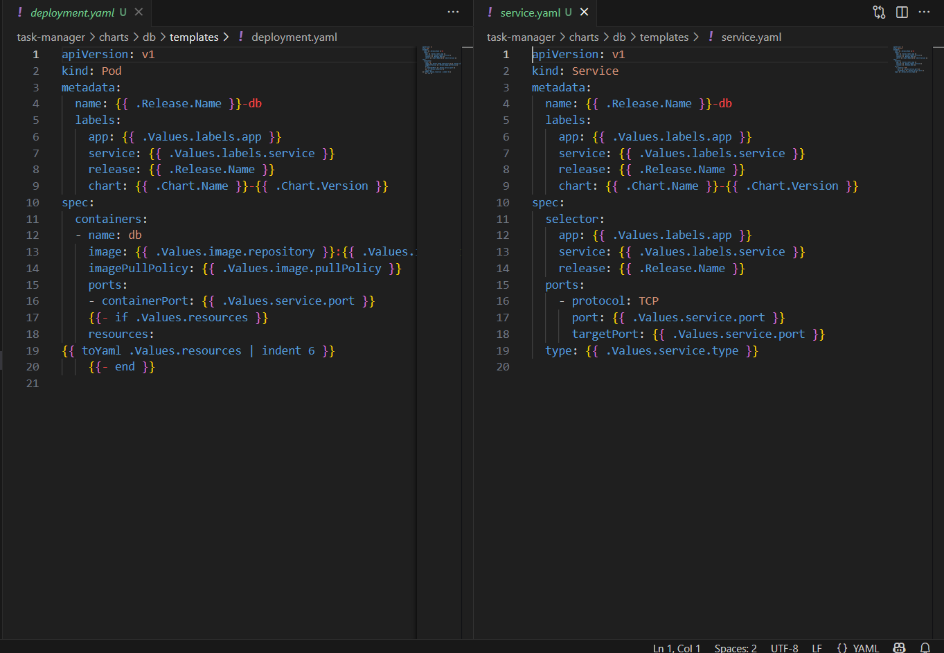
4.4. Front end
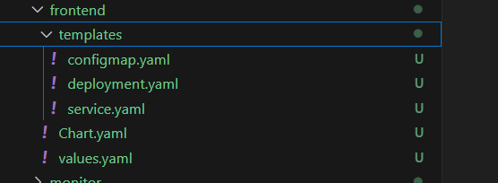
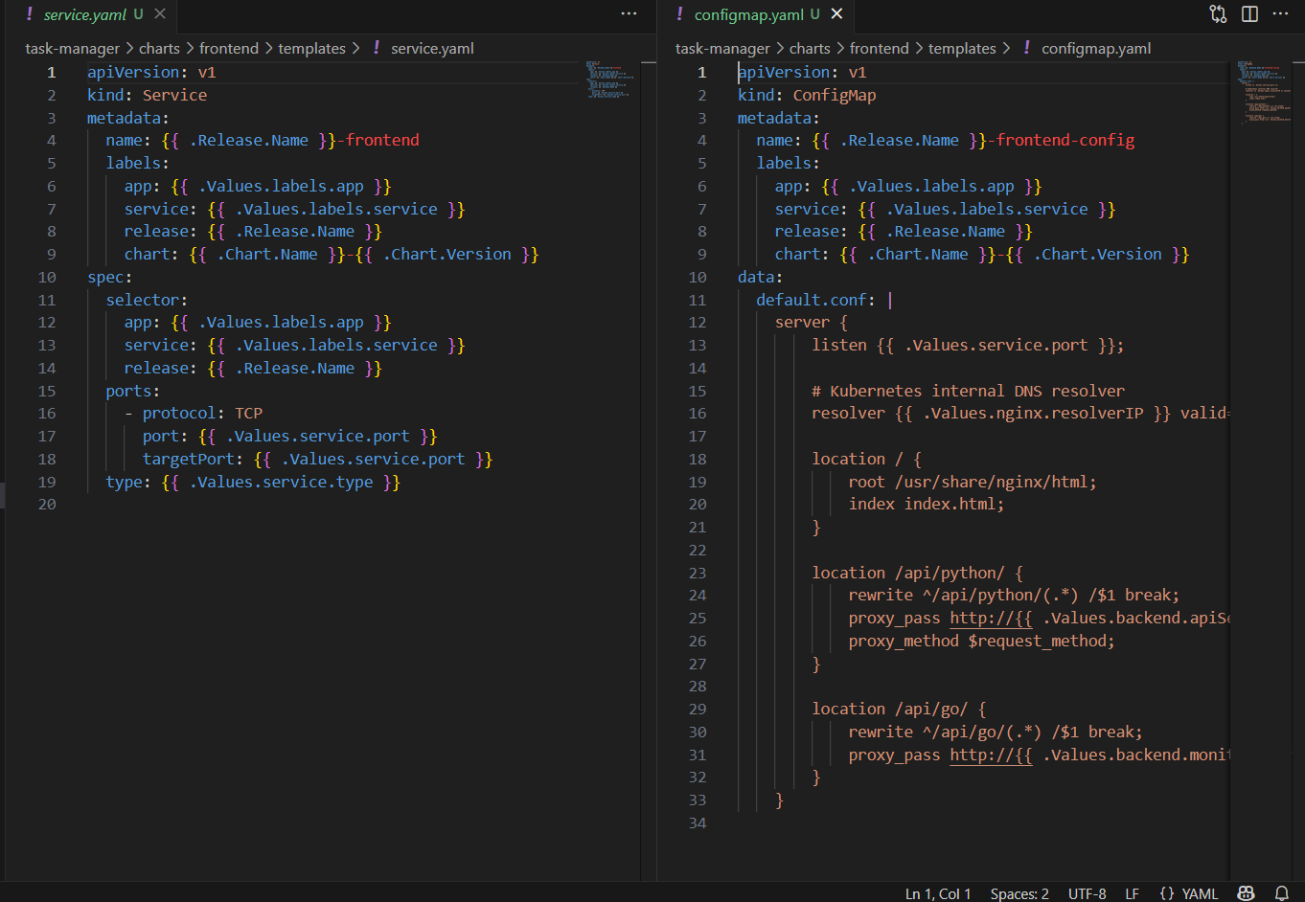
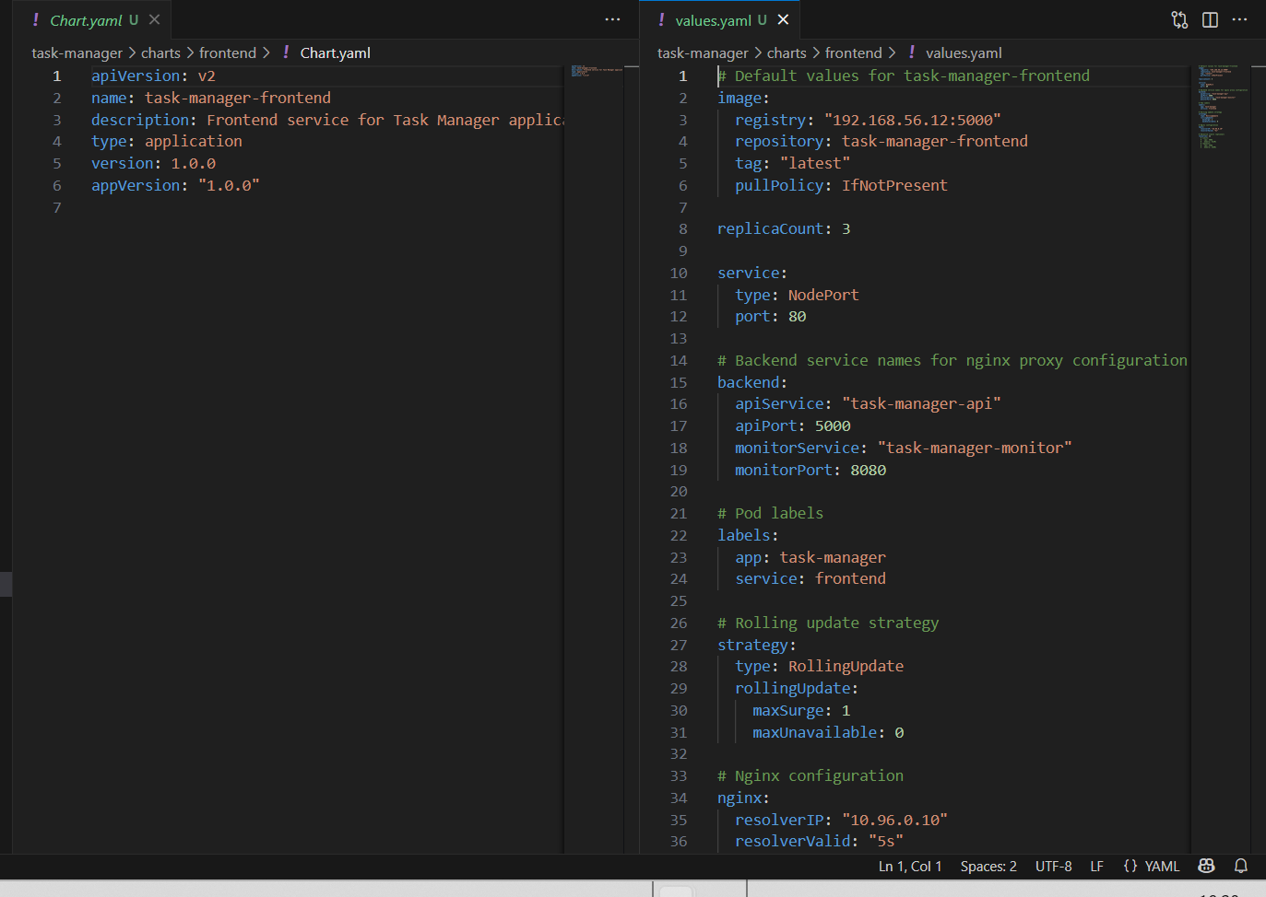
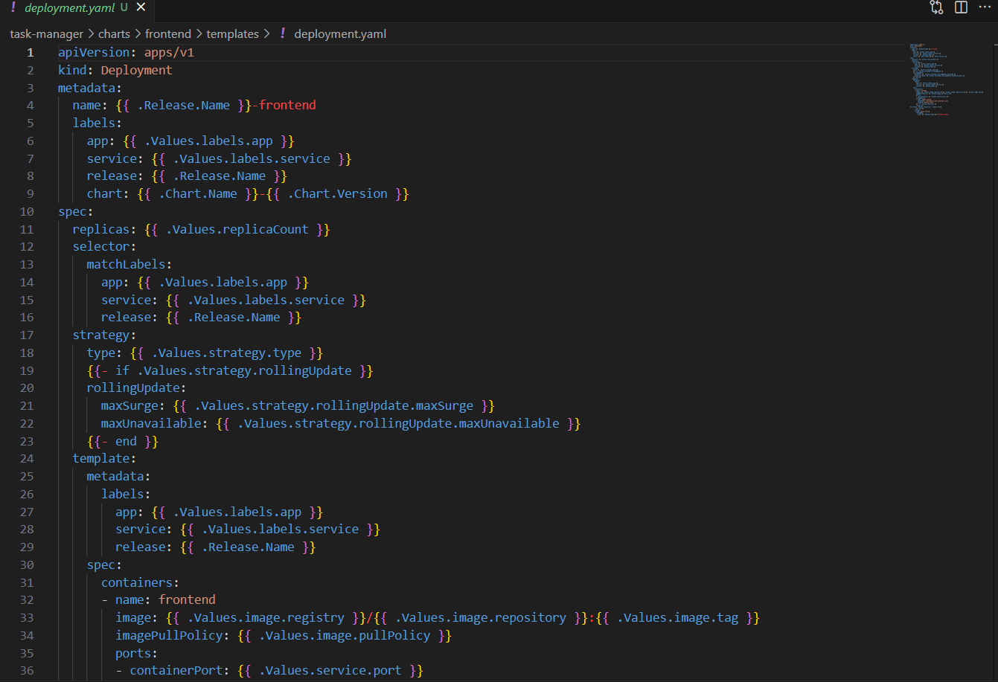
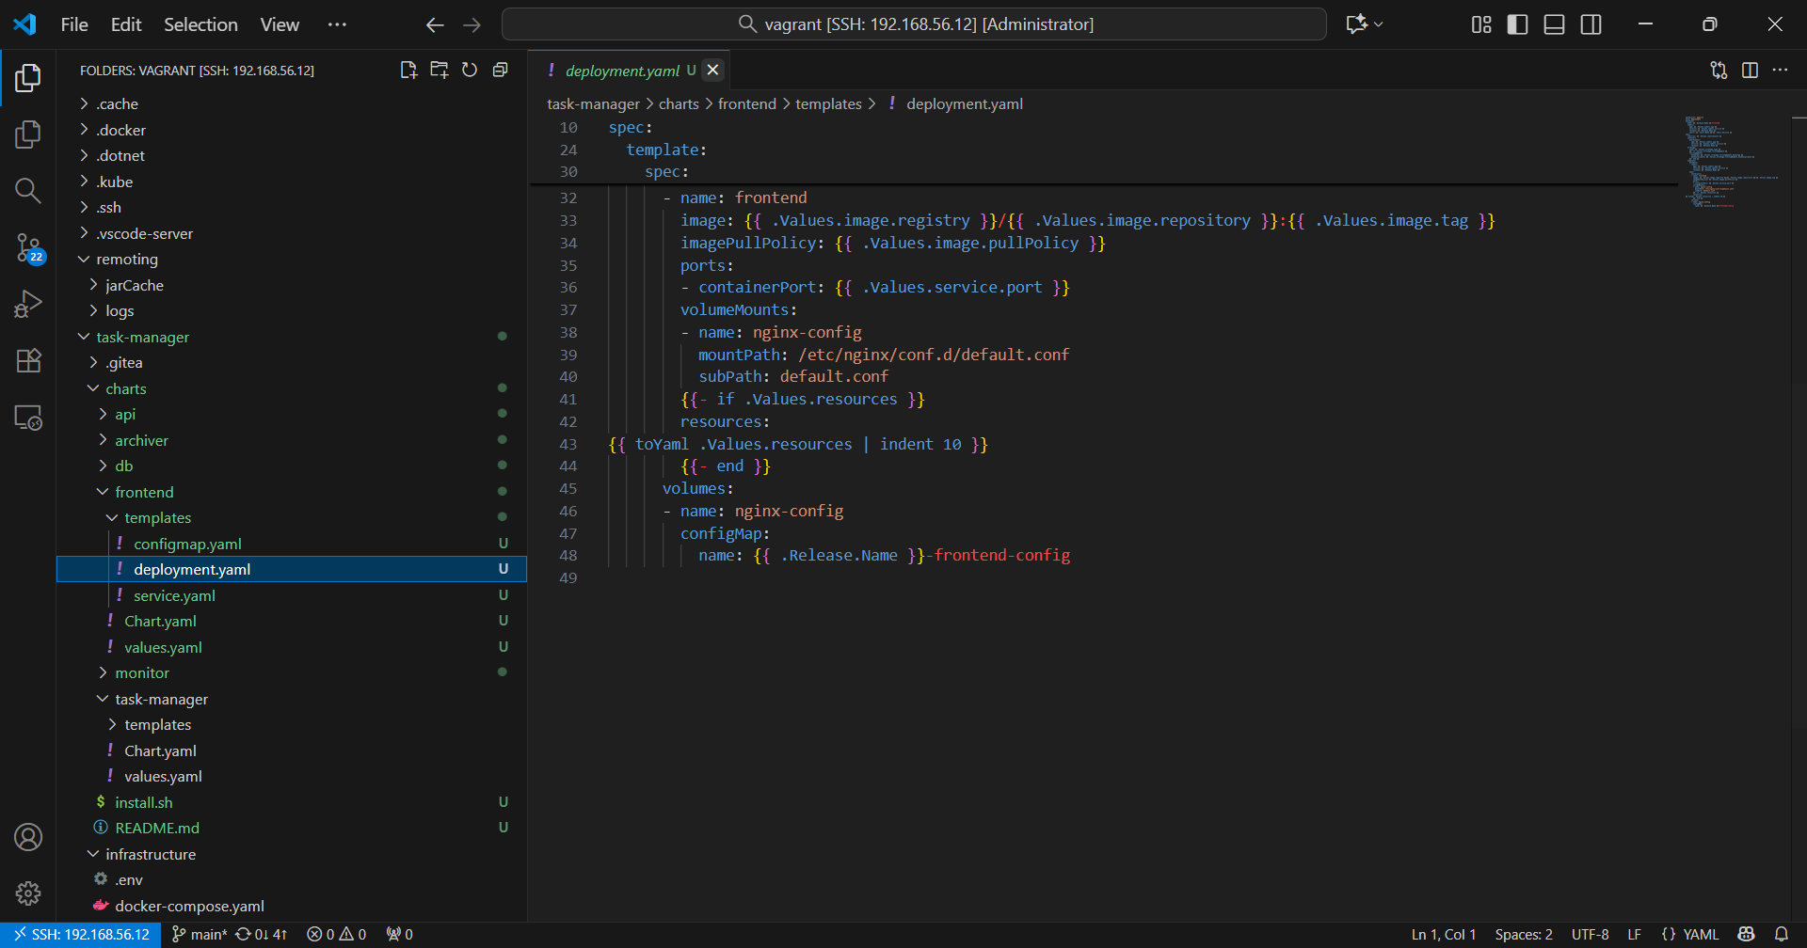
4.5. Monitoring
